**Create And Configure IBM Cloud Services**

**Create Node-RED Service**

|  |  |
| --- | --- |
| Date | 27 August 2022 |
| Team ID | PNT2022TMID18337 |
| Project Name | Project - IoT Based Safety Gadget for Child Safety Monitoring and Notification |

To create a web application create a Node-RED service. Steps:

1.Navigated to the App creation page

2.Enter project details and click on create

3.Click on the “Deploy your App” Button

5.Instance editor and set up credentials

6.Drag and drop components into the workspace

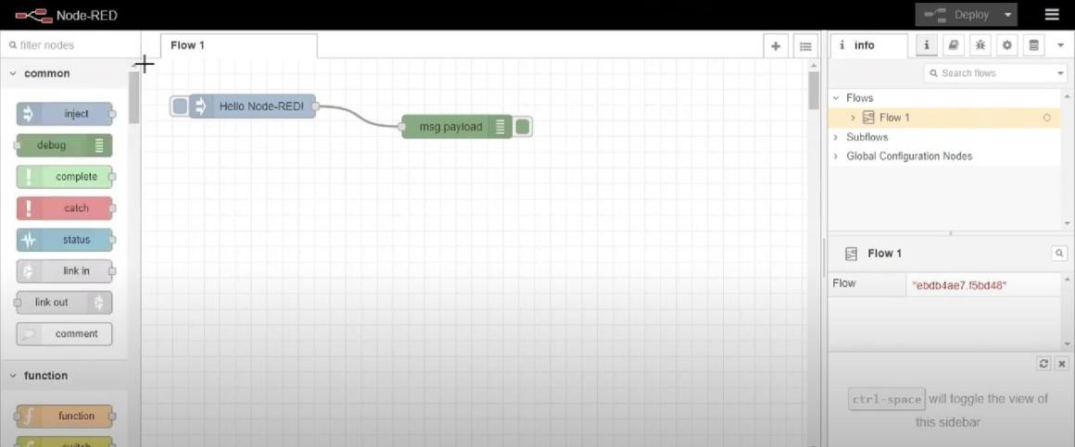

7. Deployed the app

**Conclusion**:

Created a Node RED service on IBM Cloud Successfully